Best LLM Platforms for December 2024
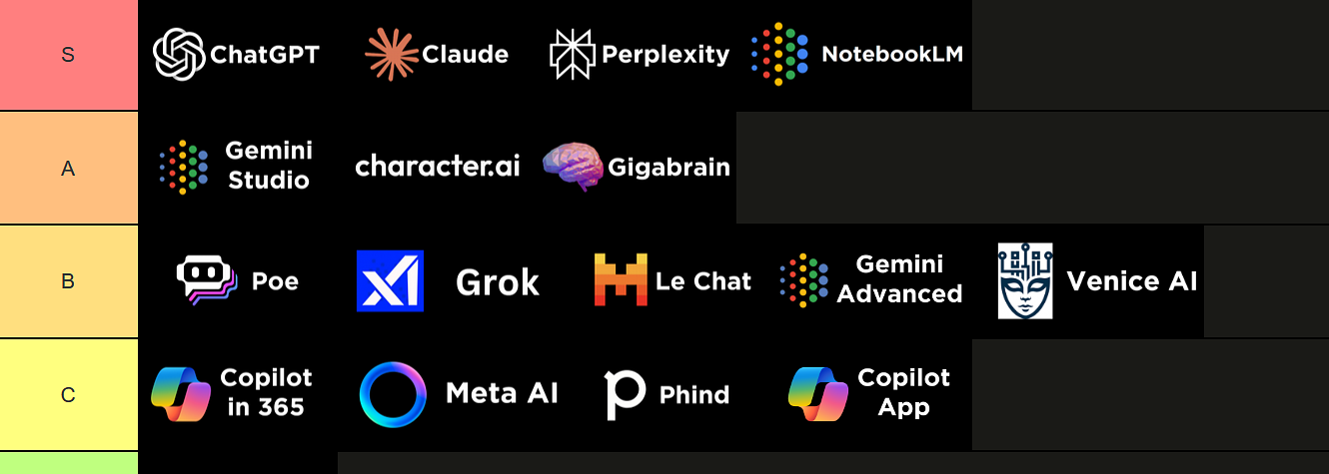



Igor Pogany
Admin🦾AIA Team🤖Member
+3
Oct 31, 2024
Founder
Introduction
We’ve put together a comprehensive ranking of the leading large language model (LLM) platforms, based on testing by our AIA Community & Team.
This list reflects the current rankings as experienced by the AIA Community & Team, and like our other lists, we'll update it once a month as the landscape evolves.
Below is a complete image of the tier list, followed by short descriptions of each platform and why it landed in its respective tier.

LLM Platform Tier List (as of December 3rd, 2024)
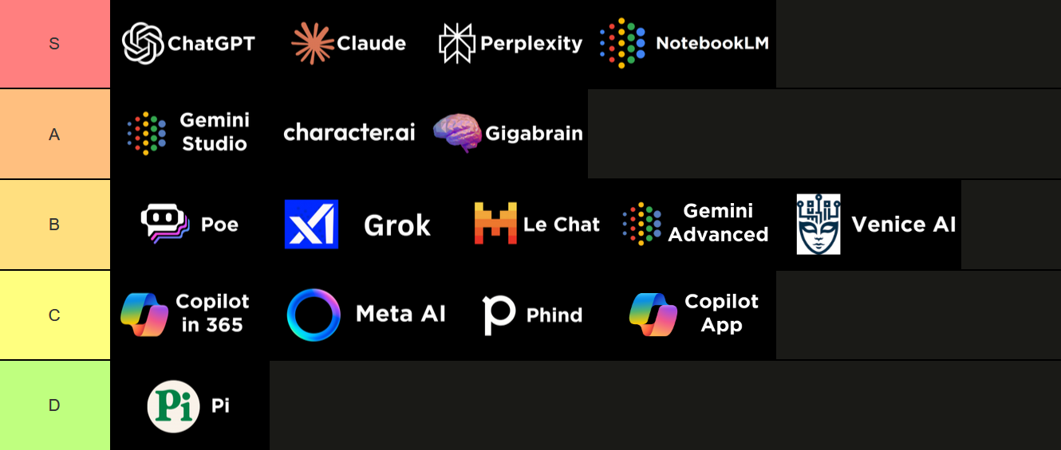

S-Tier
ChatGPT
- ChatGPT stands as the gold standard in language models, offering access to both GPT-4 and OpenAI’s latest o1 models. It now features a state-of-the-art voice assistant and provides unparalleled tooling, including a comprehensive mobile app, custom GPTs, a code interpreter, customizable instructions, voice mode, and more.
- ChatGPT’s exceptional versatility and user-friendly interface make it the go-to option for most users (250M weekly active users), ensuring a seamless and powerful experience across many use cases.
- November Update:
  - ChatGPT’s latest update in late October 2024 added the ability to search your chats back through March of 2023 and SearchGPT which is a direct competitor to Perplexity (although Perplexity seems to have some additional capabilities like searching through LinkedIn profiles which SearchGPT doesn’t allow)
- December Update:
  - Advanced voice is now available in the desktop app and on the web.
  - ChatGPT released a new model, and it feels much less predictable and formulaic—a big leap forward. While I used to rely on Claude for creative writing, ChatGPT has now become my go-to, though I still compare results when quality really matters.

Claude
- Claude excels in code generation and offers a unique, less "AI-esque" tone, making interactions feel more natural.
- Projects offer an alternative to OpenAI’s GPTs and are our favorite feature for writing as you can upload your example as a pdf and then ask it to replicate the “tone and voice” (If you just tell it to use your writing style it will also copy structure and content)
- The Artifacts feature lets you preview code that Claude creates, which makes it much easier for non-programmers to build things with code plus Sonnet 3.5 is still the best model for code generation.
- November Update:
  - Claude recently added the data analysis functionality similar to ChatGPT’s code interpreter.
- December Update:
  - Claude added the ability to see images in PDFs.
  - “Custom Styles” now available for Claude.

Perplexity
- Perplexity stands out for its search and research capabilities, offering best-in-class performance in this area.
- It beats out all its competitors due to feature richness.
- They even offer an API making it possible to integrate Perplexity into your automated workflows.
- November Update:
  - Perplexity recently added Spaces, which serves as a sort of custom generated article or web page based on your search and a Desktop App.
- December Update:
  - Perplexity Shopping launched, making it easier to find and purchase the right product using Perplexity

Notebook LM
- Notebook LM is a free AI-powered research assistant by Google that helps users organize, analyze, and create outputs from their uploaded documents and sources.
- It basically allows users to upload up to 50 sources (including PDFs, Google Docs, websites, and text files) and interact with the content through summarization, question-answering, and podcast generation.
- Notebook LM features include document summarization, chat-based interaction with citations, creation of study guides and FAQs, and even generation of podcast-style audio summaries that sound extremely good based on the uploaded content.
- November Update:
  - NotebookLM’s latest update gave users the ability to customize the prompts that the Audio Summaries use, adding entirely new options for multilingual podcasts, roleplaying scenarios and more.

A-Tier
Gemini Studio
- With it’s 2M token context window Gemini 1.5 Pro in Gemini Studio is the best model for if you need to add a lot of context (up to 2M tokens)
- Gemini Studio is the only LLM that allows for direct video upload which means you can skip the transcription step and prompt on top of video files.
- December Update:
  - Google launched two new experimental models only available through their Google AI Studio (which is free to use) and these new models topped the LLM leaderboards on launch.

Character AI
- If your primary goal is to chat with different personalities, Character AI is the best option. It offers engaging conversations and is a more affordable alternative to Poe, making it great for casual users.
- It’s particularly suited for users looking for character-driven interactions with the free plan offering all of the features most users are looking for.

Gigabrain
- AI search that only looks at Reddit making this the best choice if you are looking for opinions on a certain topic.
- December Update:
  - Gigabrain remains a solid A-tier option, especially for product reviews.
  - It’s essentially a search engine that pulls data exclusively from Reddit threads, making it great for finding real-world opinions and reviews.
  - For example, if you’re looking for the best podcasting mic, it’ll pull Reddit discussions to give you detailed feedback. It’s free and really shines for this niche use case.

B-Tier
Poe AI
- Poe offers impressive bot customization and access to multiple top-tier models for $20/month, providing a flexible platform for experimenting with various LLMs.
- In september they added o1-preview with file uploads. As of today this is the only LLM platform adding this features which is particularly useful as providing additional context to o1-preview is a great way to take full advantage of its reasoning capabilities (as discussed in the lastest LLM Innovation event What Can You Use ChatGPT o1-Preview For - LLM Innovations
- While it’s versatile, it doesn’t quite reach the polish or performance of S-tier platforms, but it’s a solid option for users looking to explore different models.
- December Update:
  - Poe remains a versatile option for accessing various LLMs in one place. It’s particularly useful for file uploads with GPT-4.0 preview, which no other platform currently offers.
  - For $20 a month, you get access to multiple models, including Gemini, Claude, and ChatGPT. It’s an excellent value.

Grok by xAI
- Grok has been doubling down on features recently. It used to excel primarily at image generation, but now it offers integrated prompt suggestions and a unique, fun interface.
- It also includes Twitter data integration, though the functionality isn’t quite as reliable as I’d like. One standout feature is its developer platform, which makes implementation incredibly simple—just swap out a single line of code to integrate Grok into your existing projects.
- That said, its base LLM is just okay, landing somewhere below the likes of Mistral.

Mistral Le Chat
- Mistral Le Chat is an easy way to test new releases from this innovative company, but the app itself doesn’t offer much beyond that.
- It’s more of a testing ground for new models than a fully-fledged LLM platform.
- NEW: As noted by community members in LLM Office Hours it now offers a completely free alternative to GPTs. The “Mistral Agents” which you need to create in their La Platfoerme.
- December Update:
  - It now offers PDF uploads, image generation, and GPT-like agents that can hold instructions or specialized tasks.
  - It’s a free alternative to ChatGPT with impressive capabilities, so I’d rank it in the B tier, possibly even above Gemini Advanced.

Gemini Advanced
- Gemini’s integration with Android phones is a standout feature, offering seamless extensions that work well with popular Google services like YouTube, Maps, and Flights.
- It’s more of a niche tool that fits well within the Google ecosystem rather than a broad-use LLM platform.
- NEW: Now with the addition of Gems (GPT type assistant) you can easily interact with your Gmail account or other Google services like Maps or Sheets.

Venice AI
- This uncensored LLM allows for 25 messages on the free plan without logging in and you can essentially ask it anything.
- These models are particularly valuable for users who need to bypass the restrictions found in more mainstream models.

C-Tier
Copilot 365 Integration
- This is the LLM you’ll use if you:
  - A. Work in a corporation that restricts AI tool usage
  - B. Spend a lot of time in Microsoft Word, Excel, Powerpoint or Teams and you want to avoid the roundtrip to ChatGPT.
- With the September Wave 2 update, it is now surprisingly useful across all apps whereas before it was very limited and many expected features just didn’t work.
  - For example: Now you can easily go from a single word to a complete PowerPoint presentation in seconds which makes a great starting point or Excel built-in advanced data analysis tools that can be accessed by simply asking copilot in natural language.
- However, this was moved down from A-Tier to B-Tier in the November update and then from B-Tier to C-Tier in the December update due to community reports that the functionality is underwhelming.

Meta.ai
- This platform lets you test Llama 3.1 and even offers image generation, but it doesn’t have many features beyond that and there are better more feature rich platforms in the higher tiers.
- It’s a good entry point for testing LLaMA models, but it lacks the depth and utility to compete with higher-ranked options.

Phind
- A developer focused perplexity that was suggested in the latest LLM Office Hours. If you want to search the internet for coding related questions, this is the tool for that.

Copilot App
- The only reason to use the Copilot app is if your company forces you to. It lacks the versatility and functionality of S-tier options, making it more of a requirement than a choice.
- If you have the option, use an S-tier platform instead for a far better experience.

Useless Tier
Pi by Inflection
- Pi has a good voice mode and cool memory features, but it doesn’t offer enough right now to earn a stronger recommendation.
- It’s a decent platform, but it’s missing the advanced tooling and robustness found in higher-tier options.
Your AI Assistant Kit: 12 Practical Tools by Wonder Tools 😲
Boost your creative work without the learning curve ✨ with an AI tool rich introduction.
Listen to This Page·8 min


Michael Spencer
and
Jeremy Caplan
Dec 18, 2024
∙ Paid

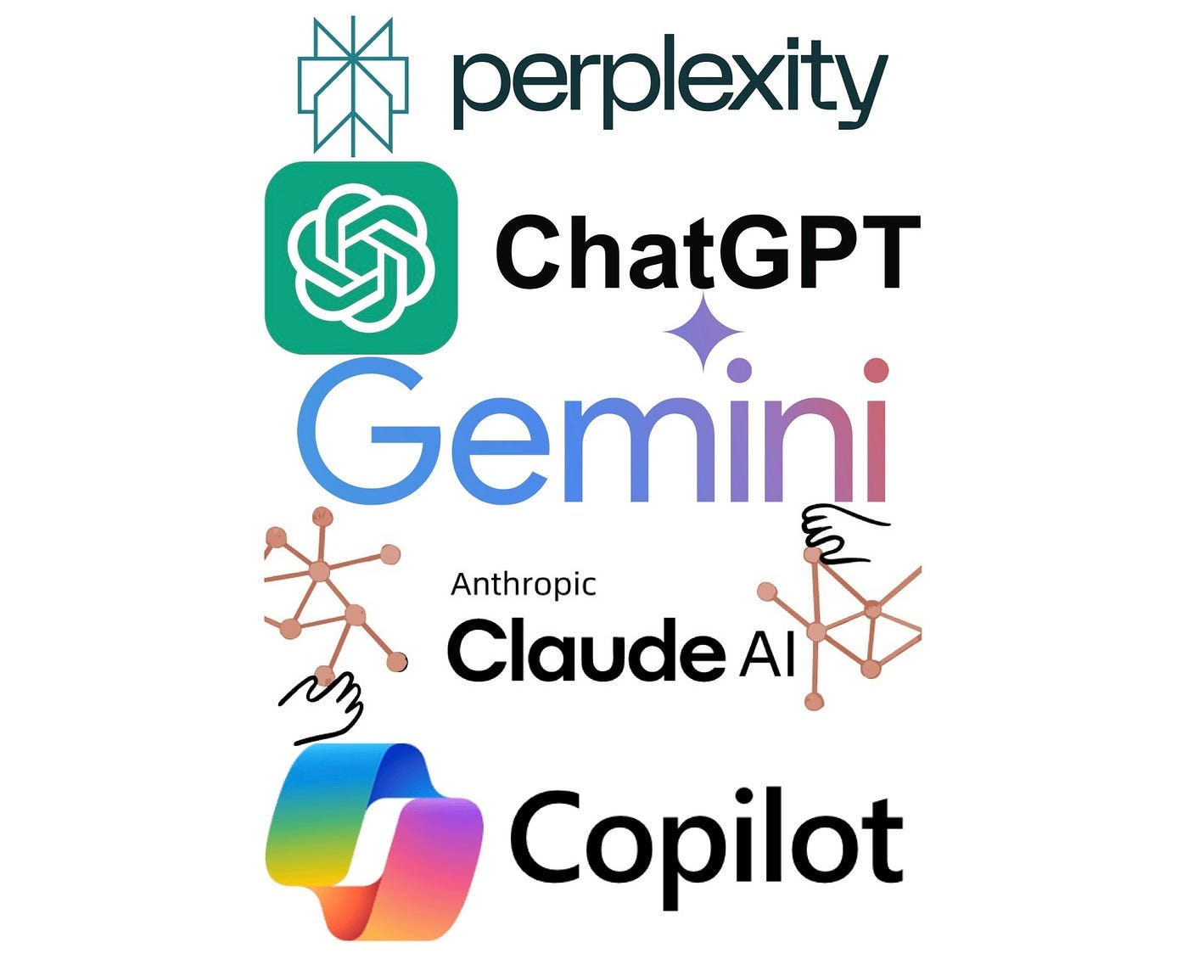

Share
AI Supremacy (read archives) is a reader supported publication, sharing our work helps us grow and is very much appreciated. I will be giving out 3-month free complimentary paid subscriptions to our top sharers and restackers every two weeks. 🙏 🇮🇳, 🇳🇬, 🇵🇰, 🇵🇭, 🇧🇷, 🇮🇩, 🇲🇽.

In 2024 we’ve covered guides to the likes of Perplexity, NotebookLM and done many other AI tool explorations and deep dives as well as exploring the short history of Prompt Engineering. You can look forwards to many other AI Tool deep dives in 2025 on this publication.
Get Full Access
There are many writers with a focus on AI tools that I want to feature, and chief among those is
Jeremy Caplan
(Jeremy Caplan) of Wonder Tools. Jeremy is a swiss-army knife of AI coverage and the future of journalism since he’s the Director of Teaching and Learning at CUNY's Newmark Graduate School of Journalism. He writes the Wonder Tools newsletter to help people discover the most valuable sites and resources for productivity and creativity.
Writers like Jeremy Caplan, Rich Holmes and Sahar Mor really elevates the genre when it comes to AI tool exploration. The value proposition for Newsletters that focus on AI tool explorations are clear:
Why Invest, Study and Use AI Tools?
- 🚀 Make professionals more productive
- ⏳ Saves you time
- 🔎 Discover new tools to do stuff, improve research and be organized
- 💼 Work smarter, not harder
- 🌱 Grow new side gig businesses and opportunities
- 📈 Increase career goals and lifetime income brackets
Join Wonder Tools
Wonder Tools
Wonder Tools helps you discover the most useful sites and apps
By Jeremy Caplan

This is also why so many Product Newsletters in 2024 focused on AI like Marily Nika, Paweł Huryn, Elena Verna and others.



Jeremy Caplan writes easy to read summaries on AI tools, workflows and offers his readers tips, tricks and new discoveries for real world use cases. I would especially recommend Wonder Tools for beginners but even early AI adopters will find value in his summaries, insights, deep dives and interviews.

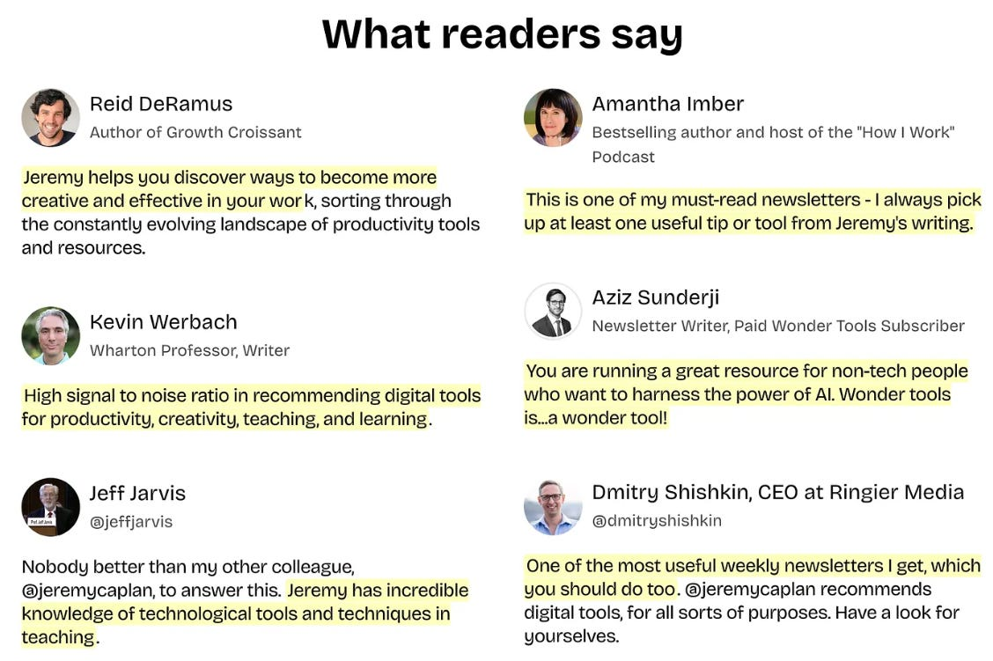

Voluntary Support for Wonder Tools
Wonder Tools List
The vast majority of his articles are free. I want to explore some of his best pieces, you might want to as well:
- Wonder Tools 🏆 Awards: Best of 2024
- Wonder 😲 Tools — AI turns ideas into apps
- 🧠 Declutter Your Tasks, Notes & Docs 🗄️
- 💬 Wonder Tools 🤖 7 ways to Use ChatGPT
- 😎 Try these Google Docs Tricks (11 of them 🤔💭)
- 🤯 What's new in Google Docs 🎊
- 🦾 Browse directory of Wonder Tools

Why can we call these Wonder Tools?
“🌊🗝️🤗 Whether you are looking to make music with AI, generate AI videos, proofread your writing, create web applications, generate images, paraphrase original sources, repurpose and curate videos, visualize design branding, streamline video production, use AI to automate LinkedIn posts, create Presentations or slide decks, YouTube channel ideation, do advanced research, operationalize lead generation & conversion, build websites, automate meeting transcripts, level-up project management, plan your day and tasks with AI, remote team collaboration, SEO aligned high-volume content marketing, note-taking and documentation, organizing personal notes, web search summarization, enhancing coding efficiency or run and fine-tune open-source models: in 2024 there’s a “Wonder Tool” for you, and in 2025 it’s only going to get better, cheaper and easier to use them! 🌍”
Share
- Consider sharing this with a friend, colleague or business associate. (💎 each of these links (above) are valuable ‘Wonder Tools’ vetted by me today that show popular consumer demand and (presumably) utility.



- If you signed up to Wonder Tools, you can expect his Emails on Thursday with useful sites & resources to save you time. Who doesn’t like the productivity boosting potential of using AI?
Read this post on the Web
Your AI Assistant Kit: 12 Practical Tools
Boost your creative work without the learning curve
A guest post by
Jeremy Caplan
of the Newsletter Wonder Tools.

Want some shortcuts to enhance your creative work and boost your productivity? Here are 12 useful AI tools that will help you clean up audio, design lively visuals, or gather quick info for anything you’re working on. You remain in charge — these services don’t replace you, they empower you. Each of these free or low-cost tools can save you time and expand the possibilities of what you can do at your desk.

Clean up your audio — Adobe Podcast v2
Upload audio files up to 30 mins and remove background noise. You can use this free tool to record and edit a 30-minute podcast. It’s a simpler alternative to Descript, which is what I use most often. More on what’s new in Adobe’s v2.

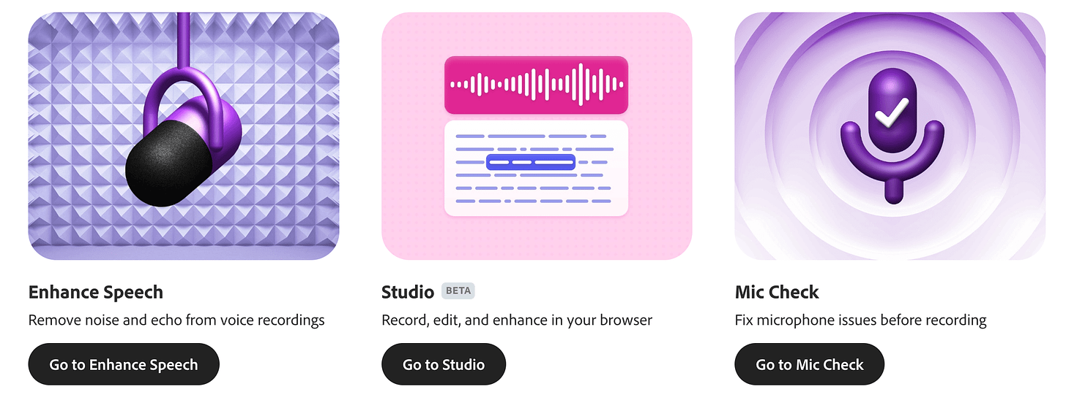

Remove a photo background — Adobe Express AI
Upload a photo (up to 40mb) and seconds later get a cutout with a blank background. You can download the image or add a background and other graphics with the Adobe Express editor.

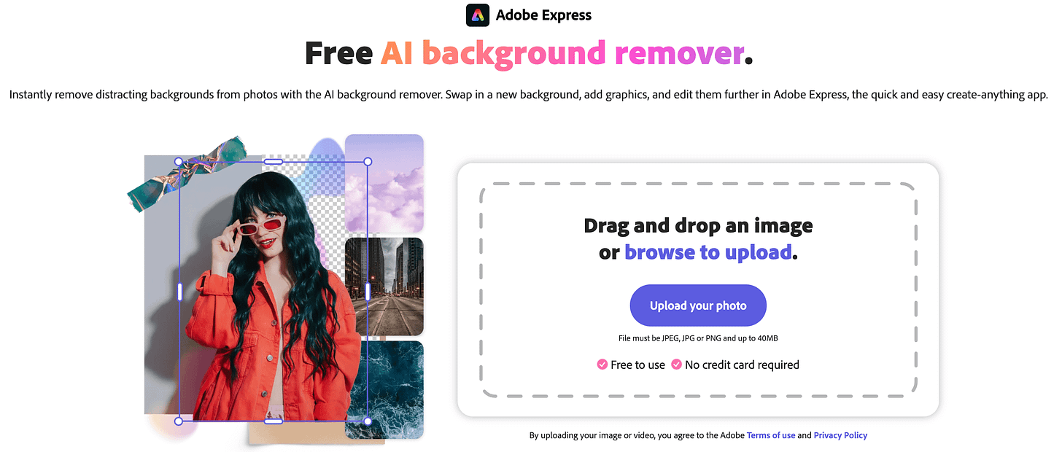

Train AI on your writing style — Claude
Give Claude a sample of your writing or describe your style. This new feature enables Claude to write an email, a meeting summary, or anything else in your style. Here’s Anthropic’s brief announcement.



Revitalize an old photo — Pica AI Photo Enhancer
Refresh any old photo. Pica will reduce blur, scratches and graininess. I tested it recently with a childhood picture. Get a few free watermarked restorations each day, or pay $40/year to subscribe. In my tests Remini appears to be a higher-quality, costlier alternative at $180/year. I also like Google’s free PhotoScan.



Pica helps you quickly polish up old pictures. You can try it without paying or logging in. Without a subscription, your photos will show a Pica watermark.

Test your AI skills — Google's Odd One Out
Can you spot which object is AI-generated? As the quality of AI imagery improves, it gets trickier. For a different challenge, try Say What You See to try crafting clear prompts.

Learn with an AI tutor — Poe
Chat with — or make — specialized AI bots. You can find a bot to get help with Excel formulas, practice Chinese translation, study anatomy, or generate coloring pages. I crafted a French tutor to translate and explain grammar; a Memory Aid to help with mnemonic devices; and an artist for ink-style drawings. Why I like Poe.

Make your own game — Windsurf Cascade
Code a game or application even if you’ve never programmed. Just ask for help and Windsurf will spin out code so you can start playing. Iterate by requesting adjustments in natural language. For more on why it’s so useful, read my post. Free for a 2-week trial.

Generate an infographic to depict an idea or framework — Napkin AI
Create a quick infographic explaining any concept visually. This AI-powered design tool takes text you give it—or a prompt—and instantly produces multiple visuals for you to select from. Read more about why I find it so useful.

Convert a written note into digital text — ChatGPT
Take a photo of a written note with the app, or upload one from your camera roll. Then copy and paste the digitized text into an email, your digital notebook, or anywhere else you want to use it. I wrote my first draft of this post on paper to avoid screen distractions. ChatGPT’s digitization of my sloppy handwriting was nearly flawless.

Get a briefing on any subject — Perplexity
Get a competitive analysis or a thorough explanation of any complex topic. Perplexity breaks down anything you’re trying to understand or gives you a citation-rich historical summary. Get five free pro searches a day. Concise responses are among the reasons I rely on Perplexity. Read my full take on Perplexity.

Get a free drawing — Ideogram
Use one of the best new image generators to make your own custom illustration of a scene, place, person, or object. Create images in a photographic or illustrated style. Ideogram can also render text accurately within an image. Check out some tips and examples.

Compose a short song with lyrics | Suno
Write a short prompt of up to 200 characters describing the mood and genre of a song you want to generate. You can even pick a subject for its lyrics. Try including the name of a special person, place, or event you want the song to be about. A short song you can download or link to as an audio clip
Example: Here's a song I generated about an American visiting South Africa for the first time.

